
INDIAN SCHOOL AL WADI AL KABIR
COMMON PRE-BOARD EXAMINATION 2025-26

ARTIFICIAL INTELLIGENCE (417)

MARKING SCHEME
Class: X Max Marks: 50
Date:16/12/2025 Time: 2 Hours
SECTION A: OBJECTIVE TYPE QUESTIONS

1 | Answer any 4 out of 6 (1 x 4=4 marks)
i | (b)Saying “I’m fine” with a smile | 1
ii | (c) Self-motivation | 1
iii | (a) Self-control | 1
iv | (d)Microsoft Edge | 1
v | (c) A is correct but R is not correct | 1
vi | (c)Population
2 | Answer any 5 out of 6 (1 x 5=5 marks)
i | (b)Data Collection | 1
ii | (b)Healthcare resources and treatments are distributed fairly | 1
iii | (b)Predefined rules | 1
iv | (b)Overfitting | 1
v | (c)Speech recognition | 1
vi | (c)Semantic Analysis | 1
3 | Answer any 5 out of 6 (1 x 5=5 marks)
i | (a)Testing | 1
ii | (c) Regression model | 1
iii | (a)DL can automatically extract features from images | 1
iv | (d)Mean Absolute Error | 1
v | (a)Object detection | 1
vi | (b)Stop words | 1
4 | Answer any 5 out of 6 (1 x 5=5 marks)
i | (b)Computer Vision | 1
ii | (c) To find natural patterns or groups in data | 1
iii | (b)Confusion Matrix | 1
iv | (c) To evaluate model performance on unseen data | 1
v | (b)The image is bright | 1
vi | (d)Document summarization | 1
5 | Answer any 5 out of 6 (1 x 5=5 marks)
i | (a)Machine Learning – it learns patterns from data | 1
ii | (b)unlocked | 1
iii | (a)35 | 1
iv | (b)False Negative (FN) | 1
v | (a)First pixel | 1
vi | (b)To extract features from text for machine learning algorithms | 1
SECTION B: SUBJECTIVE TYPE QUESTIONS

Answer any 3 out of the given 5 questions (3 x 2 = 6 marks)

Answer each question in 20 – 30 words.
Q. 6 | Feedback ensures that the message is understood correctly and helps improve clarity.  Example: A teacher asks students to summarize instructions to confirm understanding.  (0.5 mark for explanation+0.5 mark for example) | 2
Q. 7 | Self-discipline: Following rules or routines consistently.  Example: Waking up early every day to study.  Self-control: Controlling impulses and emotions in a situation.  Example: Staying calm when someone provokes you.  (1 mark for each) | 2
Q. 8 | Time management - the practice of planning and controlling how you spend your time to be more productive and efficient. | 2
Q. 9 | The stage is surviving. There are many entrepreneurs in the market. The entrepreneur has to remain in a competitive market. | 2
Q. 10 | Sustainable development is the development that satisfies the needs of the present without compromising the capacity of future generations, guaranteeing the balance between economic growth, care for the environment and social well-being. | 2

Answer any 4 out of the given 6 questions in 20– 30 words each (4x2 = 8 marks)
Q. 11 | “Beneficence" refers to the ethical principle of promoting and maximizing the well-being and welfare of individuals and society. It emphasizes taking actions that produce positive outcomes and contribute to the overall good, ensuring that the greatest benefit is achieved for all stakeholders involved. | 2
Q. 12 | Association Modelling – This model identifies relationships and co-occurrences between products (e.g., people who buy X also buy Y). It is different from classification or clustering because it finds rules or associations rather than predicting labels or grouping data. | 2
Q. 13 | Deep Learning (DL)  Example: Image recognition in self-driving cars or voice assistants like Siri/Alexa. | 2
Q. 14 |  | 2
  Confusion matrix | Predicted: Disease | Predicted: No disease
  Actual: Disease | 45 | 5
  Actual: No Disease | 5 | 45
Q. 15 | a) Object Detection  b) Bounding boxes mark the location of each object, allowing the system to track and identify multiple objects in the image.
Q. 16 | a) Script Bot  b) 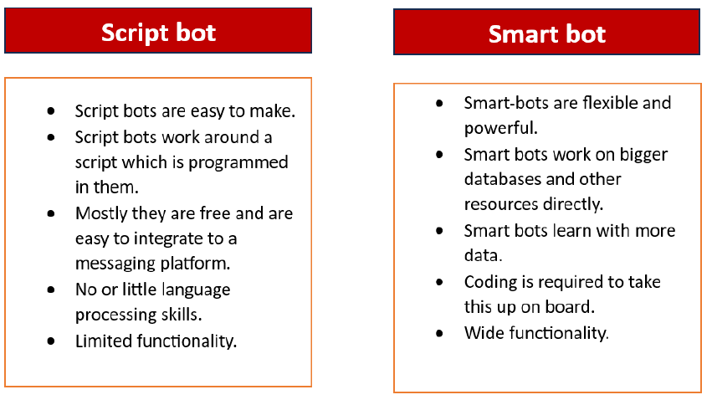

Answer any 3 out of the given 5 questions in 50– 80 words each (4 x 3 = 12 marks)
Q. 17 | Value-based Frameworks: Value-based frameworks focus on fundamental ethical principles and values guiding decision- making. It reflects the different moral philosophies that inform ethical reasoning. Value-based frameworks are concerned with assessing the moral worth of actions and guiding ethical behaviour. They can be further classified into three categories:  i. Rights-based: Prioritizes the protection of human rights and dignity, valuing human life over other considerations. It emphasizes the importance of respecting individual autonomy, dignity, and freedoms. In the context of AI, this could involve ensuring that AI systems do not violate human rights or discriminate against certain groups.  ii. Utility-based: Evaluates actions based on the principle of maximizing utility or overall good, aiming to achieve outcomes that offer the greatest benefit and minimize harm. It seeks to maximize overall utility or benefit for the greatest number of people. In AI, this might involve weighing the potential benefits of AI applications against the risks they pose to society, such as job displacement or privacy concerns.  iii. Virtue-based: This framework focuses on the character and intentions of the individuals involved in decision-making. It asks whether the actions of individuals or organizations align with virtuous principles such as honesty, compassion, and integrity. In the context of AI, virtue ethics could involve considering whether developers, users, and regulators uphold ethical values throughout the AI lifecycle.
Q. 18 | a) Type of AI learning:  - Reinforcement Learning (RL)  - Justification: The robot learns by trial and error, receiving rewards for good actions and penalties for bad actions. This feedback loop is characteristic of RL.  b) How the robot improves:  - The robot tries different actions in the environment and observes the rewards or penalties.  - Over time, it develops a policy—a strategy that chooses actions that maximize total reward.  - This allows it to navigate efficiently, avoiding obstacles and cleaning more effectively. | 2+2
Q. 19 | a) Learning type and justification:  - Past purchase data with labels: Supervised Learning  - Justification: Labels (bought/not bought) are available, so the model can learn to predict outcomes.  - Customer profiles without labels: Unsupervised Learning  - Justification: No labels are provided, so the model must find patterns or groups in the data.  b) Task type:  - Past purchase data: Classification – predicting a category (bought or not bought).  - Customer profiles: Clustering – grouping similar customers based on patterns in the data.
Q. 20 | 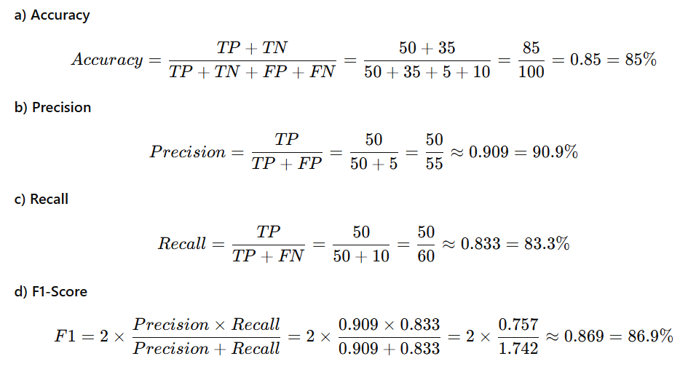 | 4
Q. 21 | a)TF-IDF stands for Term Frequency – Inverse Document Frequency.  - Term Frequency (TF): Measures how often a word appears in a document.  - Inverse Document Frequency (IDF): Measures how rare the word is across all documents.  b) Reason TF-IDF is preferred:  - Simple word counts (Bag of Words) give high importance to common words like “the” or “said” which are not meaningful.  - TF-IDF reduces the weight of common words and gives higher weight to rare, important words that help identify the key content of the document. | 4

